

Al Imam Muhammad ibn Saud Islamic University College of Computer and Information System
Computer Science Department
2nd Semester 1443 H – 2022 G

CS 438 – Internet Technologies
Project
The tortoise and the cocky rabbit

By

Student Name | ID
thar Hassan Suwaimil | 439024017
Latefah Slman Al-abdallh | 439018269
Razan Khalid Bin Zoba | 439018661

May 5 ,2022

In this project, it will take the born 1995-2005 to childhood memories of the story of the hare and the turtle, where the turtle deserved to beat the hare with its grandfather and prove itself and also not to be arrogant on the contrary with the hare, where he deserved the loss by underestimating the tortoise and the race.

1. Flow Chart

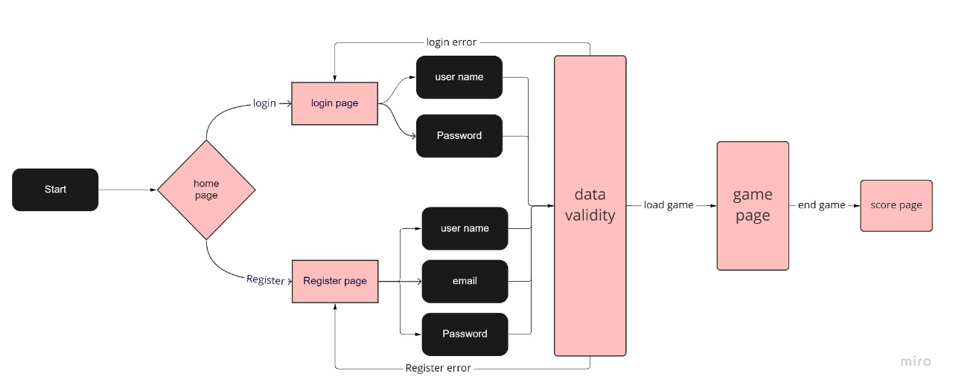

2. Look & Feel
The game's country-themed background was chosen to reflect What we heard and imagined in our memory from the story of the tortoise with the rabbit Also, a comfortable background for the eye and colors suitable for the type of game were chosen.

3. Dynamic Components
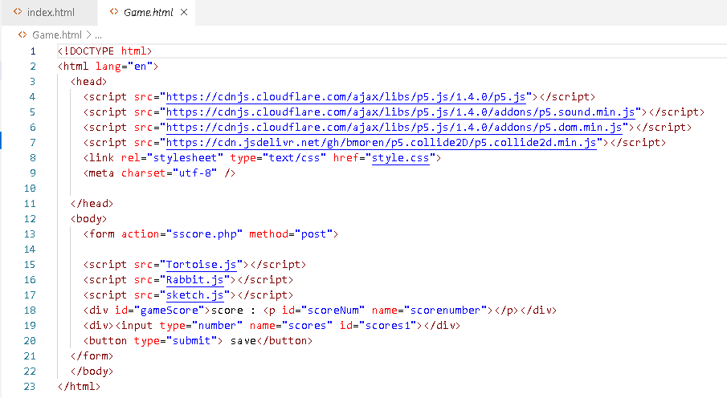
On the web page Tortoise.js a function was created for the turtle to jump called (jumpTor) and also a function for the level and length of the jump called (moveTor) and also a function if the turtle collides with the rabbit called (hitsTor_Rab) and also a function to display the image of the turtle called (showTor), the web page Rabbit.js a function for the level and movement of the rabbit called (moveRab) and also a function for displaying the image of the turtle called (showRab) were created, and on the page sketch.js function was created to display the graphics in the game, a picture of the background of the farm, the rabbit and the tortoise called (preload), and also a function to display the background and adjust its dimensions, well create an object from the Tortoise class called (setup) and a function that interacts with the user so that entering a distance is a jump from The rabbit calculates a score for the player and this function is called (keyPressed) and a function that displays the rate of displaying the rabbit and its repetition, and also if the player makes a mistake and the tortoise hits the rabbit, where the calculation of the player’s score stops, and also displaying him a "game over" and arranging the players from high to low, and this function is called (draw), and also a function that By updating the player result using AJAX, this function is called (GetValue).

4. Business Logic
The database is designed with a list to save the players’ data, the username, email and password, and also the player’s score is automatically saved to zero, so any new player registers with this information and then is included in the database. And calculating his score and summoned, and thus the players' rank is displayed.

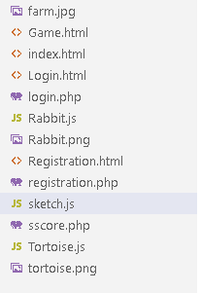
As for a call from the database, after the form is entered by the player in the (login.html) page, the data is sent to (login.php) through <form action="login.php" method="post"> and thus the data is called from the database and verify From the data entered, and also if the data sent is correct, the player is sent to the beginning of the game represented in the web page (Game.html) and for more clarification please look at the following image:
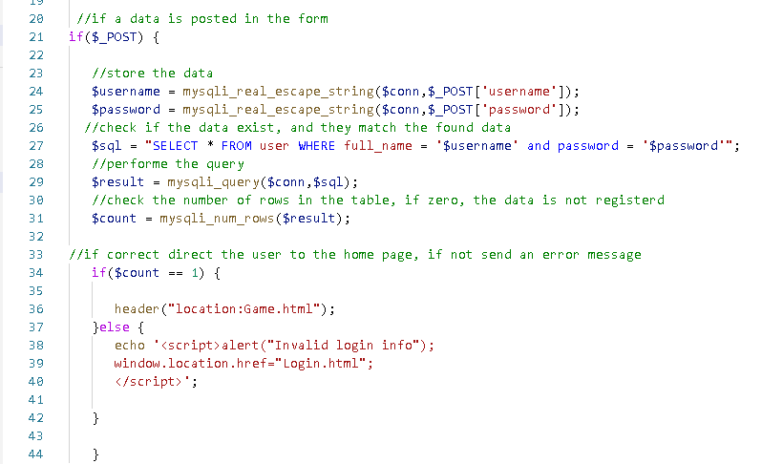
And through the code <form action="sscore.php" method="post"> in the web page (Game.html) the save button is linked with and through the page (sscore.php) and updates the player's score through this code: $ sql = "UPDATE user SET score = '$scorre' WHERE full_name= '$username'" ,the player information is called with the code:
$sql = "SELECT full_name, score FROM user ORDER BY score DESC";
$result = mysqli_query($conn, $sql);
$rank = 1;
$count = mysqli_num_rows($result);

References

(Shiffman, the coding train, 2019)

